**Lymphedema Rehabilitation (After diagnosis)**

*Complete decongestive therapy using a soft silicone based robot*

**Problem statement:**

**To design a mechatronic system to rehabilitate Lymphedema disease after the detection.**

**After the literature review, widely used and the most promising therapy towards the rehabilitation for Lymphedema is Complete Decongestive Therapy. The robot has to perform the Complete Decongestive Therapy CDT autonomously.**

**Complete decongestive therapy (CDT):**

This approach involves combining therapies with lifestyle changes. the therapy program is divided into two phases: Phase I, the Decongestion phase, and Phase II, the Maintenance phase. The goal of Phase I is to decrease the swelling in the limb to normal size, or as close to normal as possible while maintaining healthy skin. Phase II is to preserve the results of all the hard work in Phase I.

CDT Process:

1. Manual lymphatic drainage (MLD): This technique uses a scooping motion with the hand, applying pressure to manually guide trapped lymph fluid out of the affected limb or limbs.
2. compression bandaging: compression garments are used to help the body keep the lymph fluid from building up further, or from reversing the effects of the manual lymph drainage massage. Medical grade compression garments are tightest at the ankle, with a graduated lessening of pressure as they move up the leg.

CTD Period:

1. Complete decongestive therapy for one-hour sessions, 4 to 5 days per week.
2. Bandages with foam are worn about 23 hours per day and often only removed to bathe.

**Design Solution:**

A blood pressure cuff-like device that will be worn over the affected arm or leg that will roll towards the upper side of the limb using a climbing mechanism, putting pressure on the limb and moving lymph fluid away from fingers or toes.

1. The pressurized cuff: This module will be the one that applies pressure to the limb while it is in motion.
2. The climbing mechanism: This module will be a structure that houses 2 motors. The mechanism will be something similar to a pole climbing robot. This module will drag the pressured donut upwards on the limb.
3. Control and Power Module: This module will be away from the body (can be placed on the ground.) The module will house a small pneumatic pump, battery, controller, and control panel/switches.

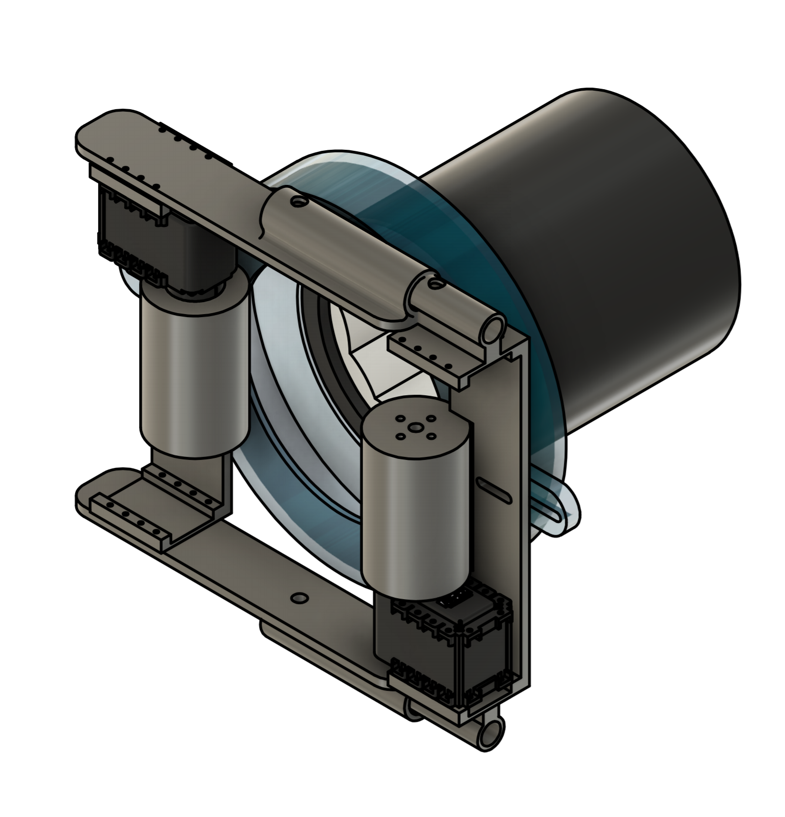

**Mechanism:**

1. Pressurized cuff: Pressure to the pressure cuff will be provided by a small pneumatic pump that is usually used in the Blood Pressure units.
2. Climbing mechanism: The mechanism has two rollers on the opposite sides to provide the main actuation for the Limb climbing. Normal reaction force between the rollers and the limb, to provide enough friction to climb will be provided by the extension springs housed two 3D printed parts.

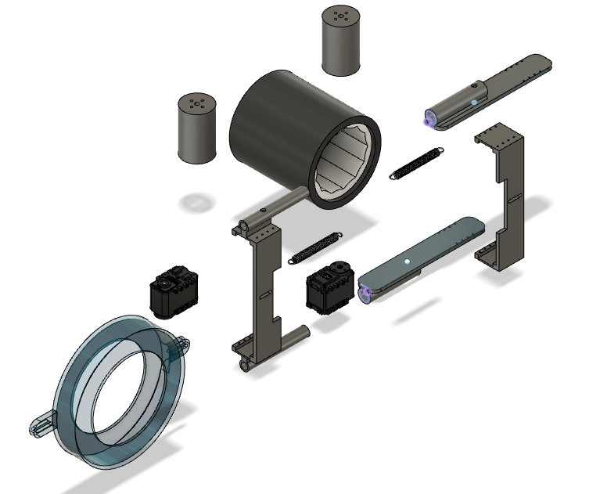

**Workflow**:

1. The design for the robot is on Version 49. All the versions for the design can be seen in the browser at this link: https://a360.co/31fvIiu

2. Current work going on for the project is trial on feasibility analysis for the limb climbing mechanism by simulating the motion.

3. The motion feasibility analysis trial is being done in Simscape and Inventor.

4. At the same time, if the feasibility of the robot is less, other mechanisms, such as a Vine robot, are being considered.